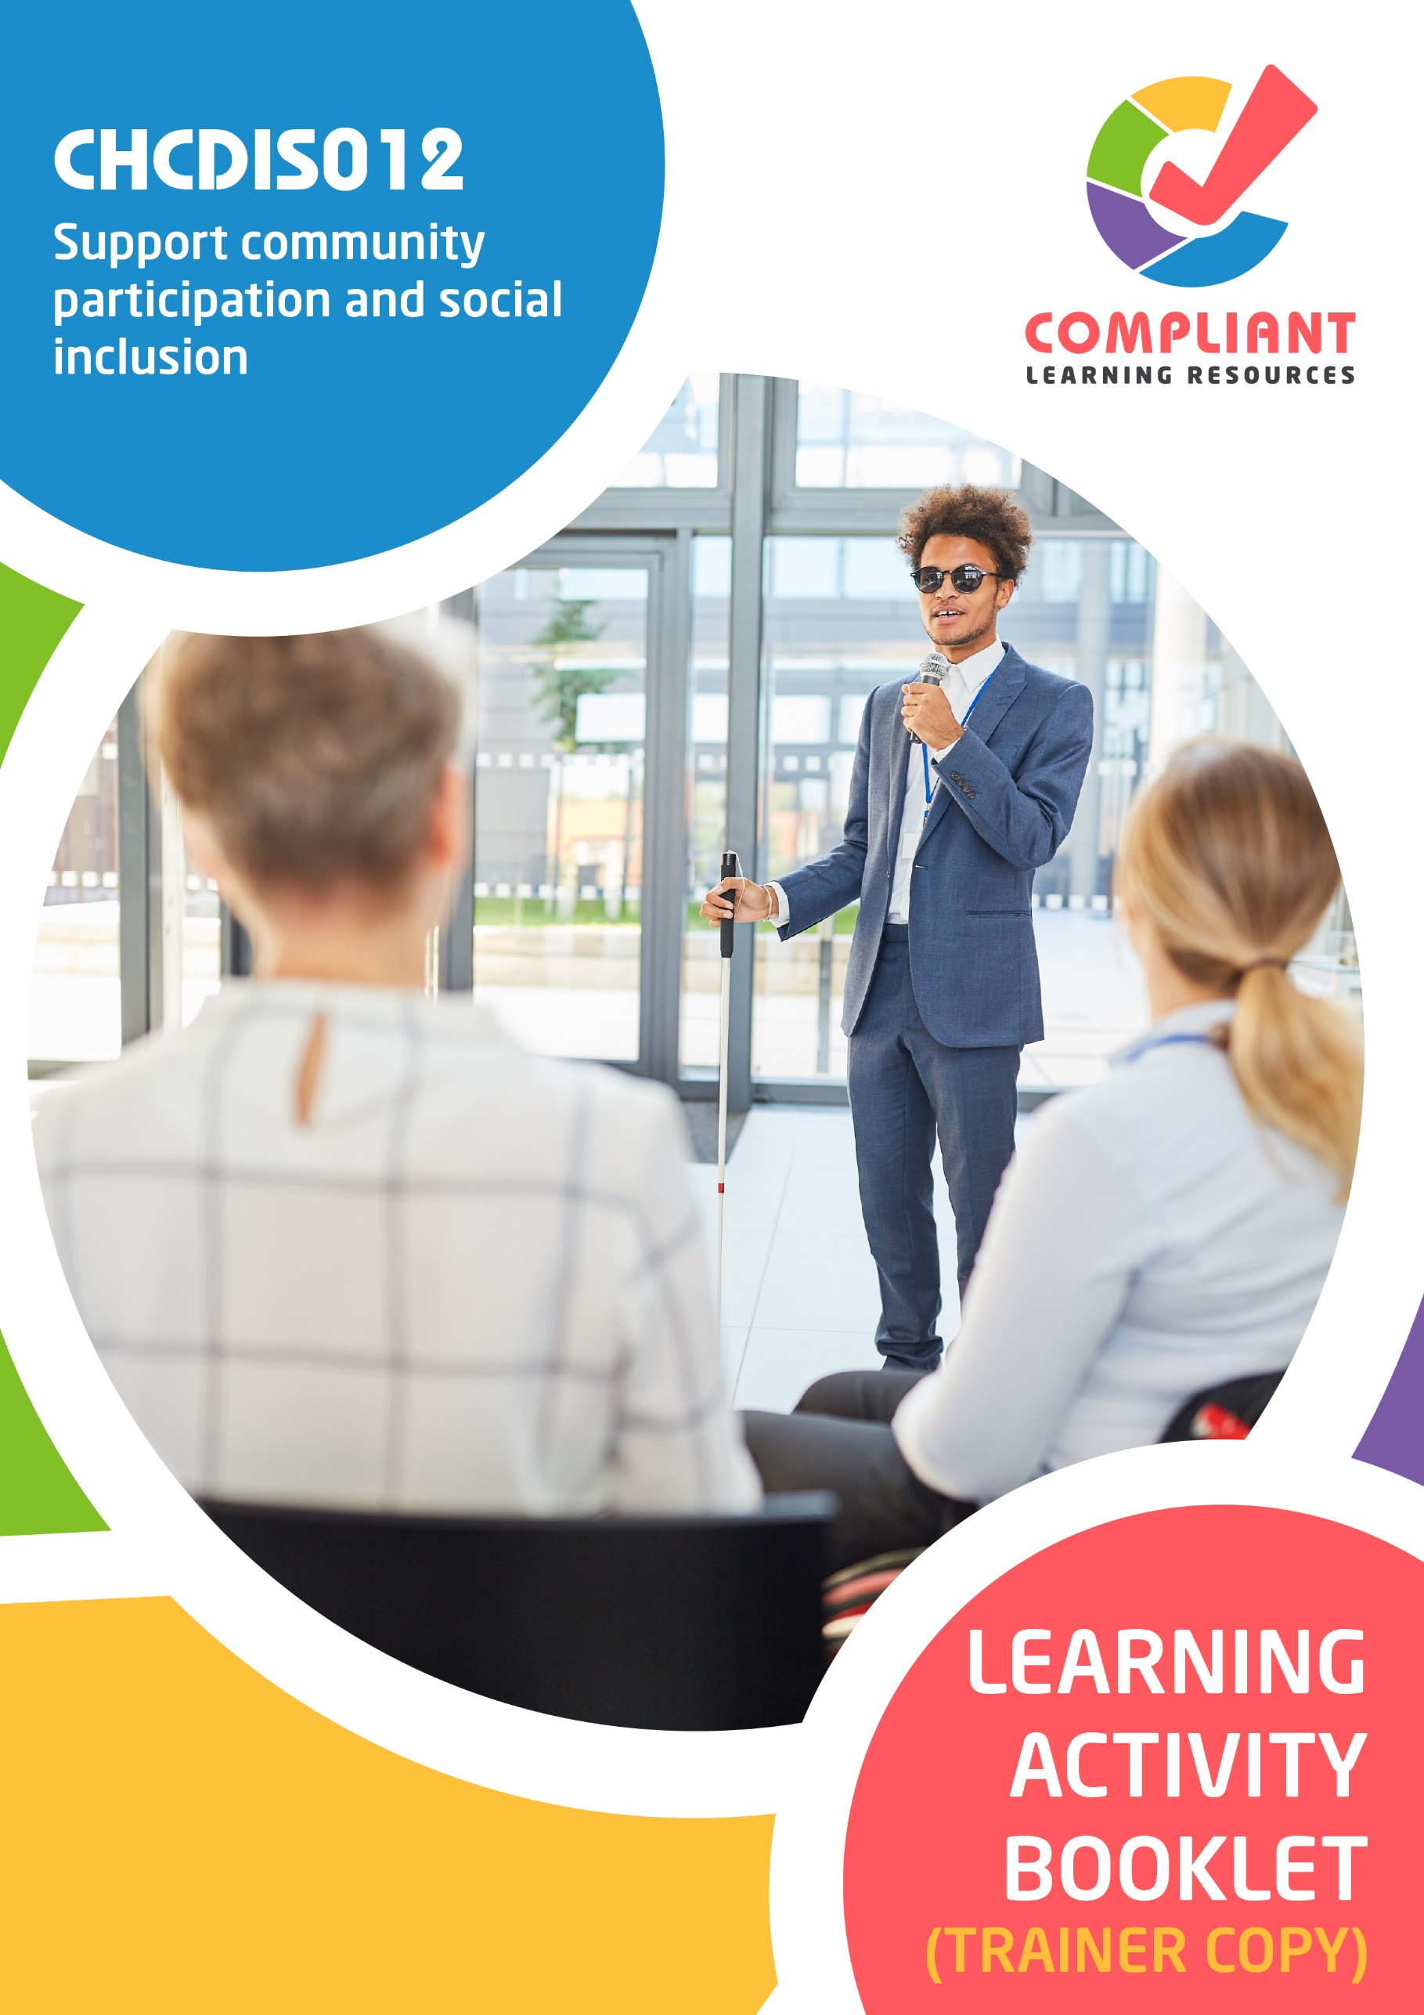

**Copyright**

This document was developed by Compliant Learning Resources.

© 2023 Compliant Learning Resources.

All rights reserved.

No part of this publication may be reproduced, stored in a retrieval system, or transmitted in any form or by any means, electronic, mechanical, photocopying, recording, or otherwise without the prior written permission of Compliant Learning Resources.

**Version Control & Document History**

|  |  |  |
| --- | --- | --- |
| **Date** | **Summary of Modifications** | **Version** |
| 13 January 2023 | Version 1.0 released for publishing | 1.0 |
| 22 August 2023 | Version 1.1 endorsed for use  Fixed wording issues | 1.1 |

# Table of Contents

Overview 4

Trainer Instructions 5

Learner Instructions 6

Learner Information 6

Trainer Information 6

Resources Required 7

Work Health and Safety 7

Reasonable Adjustment 8

Contextualisation 9

Formative Activities 10

I. Identify Opportunities for Community Participation and Social Inclusion 10

Activity 1.1 10

Activity 1.2 11

Activity 1.3 12

II. Implement Strategies for Community Participation and Inclusion 14

Activity 2.1 14

Activity 2.2 16

Activity 2.3 17

III. Identify, Address and Monitor Barriers to Community Participation and Social Inclusion 18

Activity 3.1 18

Activity 3.2 19

# Overview

**CHCDIS012 - Support community participation and social inclusion (Release 1)**

This unit describes the performance outcomes, skills and knowledge required to assist with supporting people with disability in community participation and social inclusion using a person-centred approach. This involves enabling people to make choices to maximise their participation in various community settings, functions and activities to enhance psychosocial wellbeing and lifestyle in accordance with the person’s needs and preferences.

This unit applies to workers in varied disability services contexts. Work performed requires some discretion and judgement and may be carried out under regular direct, indirect or remote supervision.

The skills in this unit must be applied in accordance with Commonwealth and State/Territory legislation, Australian standards and industry codes of practice.

No occupational licensing, certification or specific legislative requirements apply to this unit at the time of publication.

**A complete copy of the above unit of competency can be downloaded from the TGA website:**

<https://training.gov.au/Training/Details/CHCDIS012>

# Trainer Instructions

This Learning Activity Booklet contains formative activities that learners will complete in the classroom or a similar environment.

These formative activities include knowledge questions to test learners’ underpinning generic knowledge and practical activities to test their skills relevant to the unit/s of competency.

These formative assessments are used by trainers to complement both the learning and training processes, and to evaluate how learners are progressing throughout these processes.

**IMPORTANT:**

**The completion of the formative assessments and learning activities included in this workbook DOES NOT lead to a Qualification or a Statement of Attainment (SOA).**

Reasonable adjustment applies here, and while the majority of learners will complete this assessment as a written assessment, verbal assessment may be an option for those who need it. The assessor must use the marking guide as the principal marking tool unless a reasonable adjustment is demonstrated.

The Learning Activity Booklet (Trainer Copy) provides model answers to all the questions, setting out which key responses must be included as well as indicating where flexibility is acceptable.

The number of responses required is specified in each assessment task to avoid ambiguity. In these cases, the model answer will provide a list of possible answers. For instance, if a question requires the learner to list three examples, then their response must include three of the items listed in the model answer.

# Learner Instructions

This Learning Activity Booklet contains formative activities that learners will complete in the classroom or a similar environment.

These formative activities include knowledge questions to test your underpinning generic knowledge and practical activities to test your skills relevant to the unit/s of competency.

These formative assessments are used by your trainer to complement both the learning and training processes, and to evaluate how you are progressing throughout these processes.

You may reference your Learner Guide and other learning materials to complete the activities included in this workbook.

**IMPORTANT:**

**The completion of the formative assessments and learning activities included in this workbook DOES NOT lead to a Qualification or a Statement of Attainment (SOA).**

## Learner Information

|  |  |
| --- | --- |
| Learner name |  |
| Phone |  |
| Email |  |

## Trainer Information

|  |  |
| --- | --- |
| Trainer name |  |
| RTO name |  |
| RTO phone |  |
| RTO email |  |

# Resources Required

Resources needed to complete activities included in this workbook include:

* Computer with Internet, email access, and a working web browser
* Installed software: MS Word, Adobe Acrobat Reader
* Learner guide
* Volunteers to participate in a role play

# Work Health and Safety

Both the trainers and learners have duty of care in ensuring that the learning environment is free from hazards that may pose risks to their health and safety.

According to WHS legislation, trainers and learners must take reasonable care while undertaking the activities included in this workbook in the learning environment.

# Reasonable Adjustment

‘Reasonable adjustment’ in VET is the term applied to modifying the learning environment or making changes to the training delivered to assist a learner with a disability. A reasonable adjustment can be as simple as changing classrooms to be closer to amenities or installing a particular type of software on a computer for a person with vision impairment.

**Why make a reasonable adjustment?**

We make reasonable adjustments in VET to make sure that learners with disabilities have:

* The same learning opportunities as learners without disabilities, and
* The same opportunity to perform and complete assessments as those without disabilities.

**Reasonable adjustment applied to participation in teaching, learning, and assessment activities can include:**

* Customising resources and assessment activities within the training package or accredited course
* Modifying the presentation medium
* Learner support
* Use of assistive/adaptive technologies
* Making information accessible both before enrolment and during the course
* Monitoring the adjustments to ensure learner needs continue to be met

**Assistive/Adaptive Technologies**

Assistive/adaptive technology means ‘software or hardware that has been specifically designed to assist persons with disability in carrying out daily activities’ (World Wide Web Consortium - W3C). It includes screen readers, magnifiers, voice recognition software, alternative keyboards, devices for grasping, visual alert systems, and digital note-takers.

*(Adapted Reasonable Adjustment in teaching, learning and assessment for learners with a disability - November 2010 - Prepared by - Queensland VET Development Centre)*

**IMPORTANT:**

**Reasonable adjustment made for collecting learner assessment evidence must not impact the standard expected by the workplace, as expressed by the relevant unit/s of competency. For example, if the assessment were gathering evidence of the learner’s competency in writing, allowing the learner to complete the assessment verbally would not be a valid assessment method. The method of assessment used by any reasonable adjustment must still meet the competency requirements.**

# Contextualisation

Contextualisation is the process of modifying assessment tools to make learning more meaningful for your students and their employers.

Compliant Learning Resources highly recommends that your RTO contextualise the assessment tools before using them.

You must contextualise the assessment tools to suit:

* Your student’s needs
* Your RTO’s training and assessment processes
* The work and industry context in which you operate

**Contextualising for your state/territory**

The contents of this assessment tool are not written for a specific state/territory unless stated otherwise. Where the assessment tool refers to legislation and other industry requirements, which may vary across states/territories, model answers are based on one state/territory.

Should your RTO intend to use this assessment tool for learners from your state/territory, Compliant Learning Resources recommends you to:

* Access and review the legislation and industry requirements applicable in your state/territory.
* Update assessments and benchmark answers to reflect the legislation and industry requirements applicable in your state/territory.

When you are contextualising assessment tools, you must ensure that you retain the integrity of the assessment and the outcomes of the unit of competency.

**A comprehensive guide to contextualising your assessment tools for your RTO can be accessed through this link:**

<https://compliantlearningresources.com.au/blog/simple-guide-to-contextualising-rto-training-resources-and-assessment-tools/>

# Formative Activities

## I. Identify Opportunities for Community Participation and Social Inclusion

### Activity 1.1

|  |  |
| --- | --- |
| **True or False**  Review the statements below about consulting with persons with disability to determine their support requirements for engaging with a social network. Indicate whether each statement is True or False.  Tick the box that corresponds to your answer. | |
|  | |
| *Mapping: CHCDIS012 PC1.1, KE2.2 (p), KE6.0*  *Learner guide reference: CHCDIS012 Learner Guide, Chapter 1, Subchapter 1.1* | |
| TRUE  FALSE | 1. Preferences refer to what ideas and activities that the client wants to learn and participate in. |
| TRUE  FALSE | 1. Manner of participation refers to how persons with disability will interact with others within their social networks and communities. |
| TRUE  FALSE | 1. When a person with an impairment interacts with society, they often experience discrimination. Discrimination is the unfair treatment of people on various grounds. |
| TRUE  FALSE | 1. Active citizenship refers to being earnestly involved with one’s community. This matters for persons with disability, as they also want to work with others with the same interests, goals and preferences like everyone else. |
| TRUE  FALSE | 1. You do not need to follow the principles of person-centred practice to ensure that your clients’ opinions are heard and they will be happy with your service. |

### Activity 1.2

|  |  |
| --- | --- |
| **Matching Type**  Listed below are the community participation options.   1. Resources 2. Programs 3. Agencies 4. Services 5. Aids and Equipment   Match each to their description below, by writing the letter that corresponds to your answer in the space provided. | |
|  | |
| *Mapping: CHCDIS012 PC1.2 (p)*  *Learner guide reference: CHCDIS012 Learner Guide, Chapter 1, Subchapter 1.2* | |
| Description | |
| c | 1. These refer to organisations that provide specific services for persons with disability to aid them in participating in their community. |
| a | 1. These refer to sources of information on how persons with disability can participate in their community. |
| b | 1. These refer to activities and initiatives conducted by different organisations with the goal of supporting persons with disability in community participation. |
| e | 1. These refer to assistive technologies (AT) that helps persons with disability fully participate in their communities. |
| d | 1. These refer to transport services and health services that are relevant to supporting persons with disability in participating in their community. |

### Activity 1.3

|  |
| --- |
| **SCENARIO**  You are a disability support worker from a community centre in Victoria. One of your clients is Maggie Summers, a ten-year-old girl with full vision loss. She loves being in the water and is a big fan of the Paralympics. She shares with you that her biggest dream is to be a Paralympic athlete. Maggie wants to learn how to swim.  Maggie’s parents want to support Maggie’s interest in swimming, but they are worried about her safety around water. Maggie has only been in shallow pools where the water only reached up her knees. They are also worried about the availability of sport programs for children who have full vision loss. |

|  |
| --- |
| List down two pieces of community information about swimming programs that you can provide to Maggie and her parents. |
|  |
| *Mapping: CHCDIS012 PC1.3, KE5.0 (p)*  *Learner guide reference: CHCDIS012 Learner Guide, Chapter 1, Subchapter 1.3, Section 1.3.1*  **Marking guide**  The learner must list down two pieces of community information about swimming programs that you can provide to Maggie and her parents.  For a satisfactory performance, their responses must be pieces of information relevant to swimming. This includes information about local resources, programs, agencies, services, aids and equipment that cater to swimming for persons with disability. Examples of acceptable responses include:   * Examples of other person with full vision loss who swim professionally * Benefits of swimming * Local swimming programs for children with visual impairments * Accommodations given to persons with disability in different swimming pools near the client |
|  |
|  |

|  |
| --- |
| Explain how you can ensure Maggie will get the resources she need to swim. |
|  |
| *Mapping: PC1.3, KE5.0 (p)*  *Learner guide reference: CHCDIS012 Learner Guide, Chapter 1, Subchapter 1.3, Section 1.3.2*  **Marking guide**  The learner must explain how they can ensure Maggie will get the resources she need to swim.  For a satisfactory performance, their response must be actions that they can do to secure the necessary resources that Maggie needs to participate in swimming as a person with full vision loss. An example of a satisfactory response is provided below. |
| I will need to look for a trained swim coach who has experience with people who have full vision loss. I will also need to identify and find any special swimming equipment Maggie will need. I can also help Maggie and her parents get these resources approved by their insurance provider. |

## II. Implement Strategies for Community Participation and Inclusion

### Activity 2.1

|  |
| --- |
| **SCENARIO**  You have been assigned to be the disability support worker of Becky Fields. Becky is a young adult with autism who has difficulties with socialisation. During your discussion with Becky regarding her individualised plan, you learn that Becky loves activities that involve books.  As her disability support worker, you are tasked to find social activities for Becky that focus on reading. During your research, you found that the local library has a book club program for people with intellectual and developmental disabilities to read, learn and socialise with others. Each club has at least four members and two volunteer facilitators who are trained to engage readers of all levels.  In your next meeting with Becky, you bring up the book club program as an option for Becky to build her social skills. Becky is excited by the idea and wishes to join the program. She will need your support in accessing the option. |

|  |
| --- |
| **Role Play Activity**  Role play the scenario with a volunteer to support the person with disability in accessing community participation program while demonstrating the practical skills listed in the checklist below.  Perform this activity while being observed by your trainer. If your trainer is not available to directly observe you, you may video record the role play activity and submit the recording to your trainer.  **Your role**  For this activity, you will take the role of the disability support worker  **The volunteers’ role**  For this activity, the volunteer will take the role of the client. |

|  |
| --- |
| *Mapping: CHCDIS013 PC2.1 (p), PE1.1 (p)*  *Learner guide reference: CHCDIS012 Learner Guide, Chapter 2, Subchapter 2.1*  **Marking guide**  The learner must role play the scenario provided above while demonstrating the practical skills listed below and while being observed by the trainer. The trainer must use the checklist below to evaluate the learner’s performance during the activity. |

|  |  |  |
| --- | --- | --- |
| **Role Play Checklist** (For trainer’s use only) | | |
| **During the role play activity:** | **YES** | **NO** |
| 1. The learner contacts the person/organisation who can provide the program. |  |  |
| 1. The learner provides the client with online links related to the program. |  |  |
| 1. The learner assists the client in filling out documents required to access the program. |  |  |
| Trainer’s overall feedback on the learner’s performance during the role play activity: | | |

### Activity 2.2

|  |  |  |  |  |  |  |  |
| --- | --- | --- | --- | --- | --- | --- | --- |
| **Matching Type**  Identify the assistive technology for communication being described in each statement below.   |  | | --- | | **Assistive Technology for Communication** | | FM Systems | | Eye Gaze | | Audiobooks | | Memory Aids | | Noise-Cancelling Headphones | | |
|  | |
| *Mapping: CHCDIS012 PC2.4 (p), KE10.3, KE10.5 (p), K10.6 (p)*  *Learner guide reference: CHCDIS012 Learner Guide, Chapter 2, Subchapter 2.4, Section 2.4.1* | |
| Description | |
| Audiobooks | 1. These are recordings of print materials being read out loud. |
| FM Systems | 1. These wireless devices use radio signals to connect a microphone to hearing aids or receivers. |
| Noise Cancelling Headphones | 1. These eliminate distracting background noises to prevent overstimulation. |
| Memory Aids | 1. These devices assist the person in recalling information or steps to accomplish activities. |
| Eye Gaze | 1. An electronic device that allows the person to communicate by looking at words or commands on a screen. |

### Activity 2.3

|  |
| --- |
| **Fill in the blanks**  The following are statements on strategies to address negative attitudes expressed by stakeholders community participation and social inclusion. Review each and complete the statement by filling in the missing words/phrases. |
|  |
| *Mapping: CHCDIS012 PC2.5 (p), KE14.0*  *Learner guide reference: CHCDIS012 Learner Guide, Chapter 2, Subchapter 2.5, Section 2.5.3* |
| 1. Find out       the reason behind the negative attitude. The person concerned may have       an underlying issue which causes the negative attitude. |
| 1. Focus on the behaviour of the person concerned when discussing the negative attitude. Keep your emotions       in check. Do not use the discussion as a cover for judging or critical of the person concerned. Judgement is only your       opinion of the person’s character and is not neutral. Make sure to pause and think about where the feedback is coming from and how positively the person can receive it. |
| 1. Be specific and precise. Addressing the negative attitudes should be       solution-oriented and to the point. Offering general and vague comments can leave the person confused about what they have to work on. Provide       straightforward examples of the action in question. |
| 1. Make conversations a two-way street. Take time to engage with the person concerned and check for their understanding. Let the person respond to what you said and allow them to ask       follow-up questions. This shows your       respect for the person’s opinions. It can also clear any misunderstandings you might have about their attitudes. |

## III. Identify, Address and Monitor Barriers to Community Participation and Social Inclusion

### Activity 3.1

|  |  |
| --- | --- |
| **Matching Type**  Listed below are some of the common barriers to community participation and social inclusion.   1. Physical Barriers 2. Systemic Barriers 3. Personal Barriers 4. Skill Barriers 5. Structural Barriers 6. Resource Barriers 7. Psychological Barriers 8. Stigma 9. Self-stigma 10. Discrimination   Match each to their description below, by writing the letter that corresponds to your answer in the space provided. | |
|  | |
| *Mapping: CHCDIS012 PC3.1 (p), KE12.1, KE12.2, KE12.3, KE12.4, KE12.5, KE12.6, KE12.7, KE12.8, KE12.9*  *Learner guide reference: CHCDIS012 Learner Guide, Chapter 3, Subchapter 3.1, Section 3.1.1* | |
| Description | |
| c | 1. These barriers may involve the family or cultural background of the person with disability. |
| a | 1. These barriers are structural obstacles that can affect one's ability to move freely. These barriers are found in the person’s environment. |
| d | 1. These barriers are related to the person with disability not having enough training opportunities to develop their skills because of stigma against persons with disability. |
| f | 1. These barriers may occur when there are simply no available resources that can meet the needs of the person with disability. |
| b | 1. These barriers are related to laws or policies that discriminate against persons with impairment. These contribute to the individual and emotional obstacles a person may experience. |
| e | 1. These barriers may take place when the person with disability does not have a complete understanding of the services that are available. |
| h | 1. This barrier arises when people focus on the person rather than focusing on their illness. |
| g | 1. These barriers include personal perception, lack of self-confidence, low self-esteem, negative body image, and perception of others. |
| j | 1. This barrier happens when a person with a disability is poorly treated or does not get the same opportunities as others in the same situation. |
| i | 1. This barrier is the result of internalising stigma and other negative attitudes. |

### Activity 3.2

|  |
| --- |
| Identify and describe:   1. Two strategies for systemic advocacy 2. Two strategies for individual advocacy |
|  |
| *Mapping: CHCDIS012 PC3.5 (p), KE4.0*  *Learner guide reference:*   * *CHCDIS012 Learner Guide Chapter 3, Subchapter 3.5, Section 3.5.2* * *CHCDIS012 Learner Guide Chapter 3, Subchapter 3.5, Section 3.5.3*   **Marking guide**  The learner must identify and describe:   1. Two strategies for systemic advocacy 2. Two strategies for individual advocacy   For a satisfactory performance, although the wording may slightly vary, their response must be consistent with the benchmark answers below. |

|  |  |
| --- | --- |
| **Strategies for systemic advocacy** | **Description** |
| Policy Monitoring | Policy monitoring involves observing the implementation and effectiveness of policies already in place. |
| Advocacy Campaigns | An advocacy campaign is an organised movement that aims to influence political change and bring awareness around issues to the public. |

|  |  |
| --- | --- |
| **Strategies for individual advocacy** | **Description** |
| Informal Advocacy | Informal advocacy is where the client chooses an advocate to speak on their behalf from their support system. |
| Formal Advocacy | Formal advocacy is where the client chooses an advocacy service to speak on their behalf. |

End of Document